CS5542 Big Data Apps and Analytics

**Lab-10**

ClassId Student_1 : **27**

ClasssId Student_2: **19**

1. Audio Collection Collected guitar and flute data.

Guitar

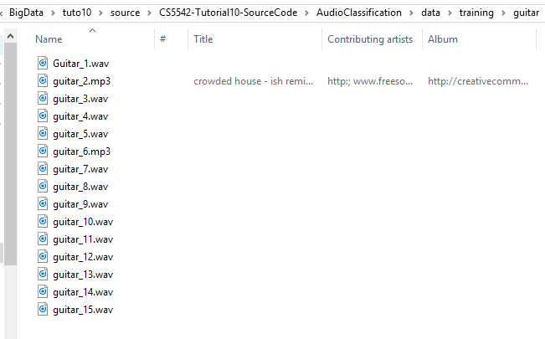

Flute:

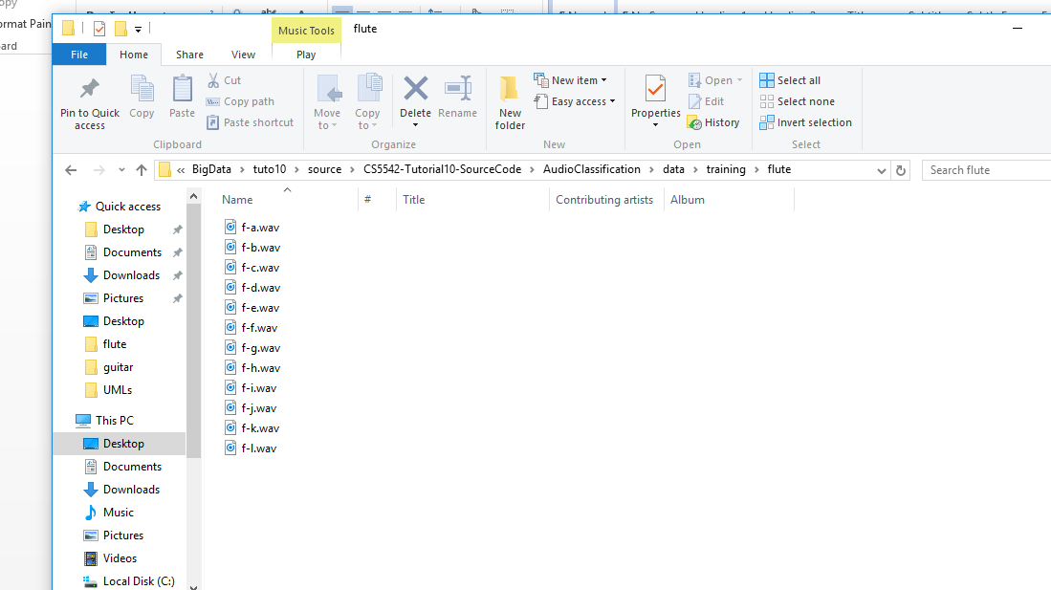

Divided into training and testing

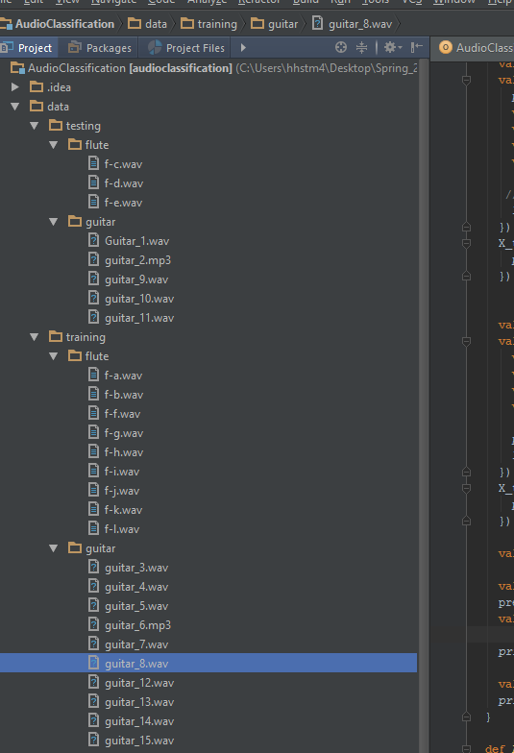

2. Audio Classification based on the categories related to your project

Generating features from Training audio data.



Generating features from Testing audio data.



Accuracy

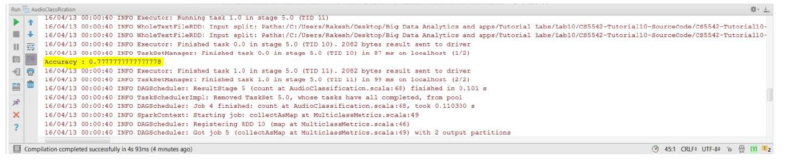

3. Notification on devices

With audio flute

